Chapter 3, Solution 30
v₁
10 Ω
20 Ω
80 Ω
40 Ω
1
v₀
i₀
2i₀
2
– +

–
+
+
–
80 V
96 V
4v₀

At node 1,

[(v₁–80)/10]+[(v₁–4v_{o})/20]+[(v₁–(v_{o}–96))/40] = 0 or
(0.1+0.05+0.025)v₁ – (0.2+0.025)v_{o} =
0.175v₁ – 0.225v_{o} = 8–2.4 = 5.6 (1)

At node 2,

–2i_{o} + [((v_{o}–96)–v₁)/40] + [(v_{o}–0)/80] = 0 and i_{o} = [(v₁–(v_{o}–96))/40]
–2[(v₁–(v_{o}–96))/40] + [((v_{o}–96)–v₁)/40] + [(v_{o}–0)/80] = 0
–3[(v₁–(v_{o}–96))/40] + [(v_{o}–0)/80] = 0 or
–0.0.075v₁ + (0.075+0.0125)v_{o} = 7.2 =
–0.075v₁ + 0.0875v_{o} = 7.2 (2)

Using (1) and (2) we get,

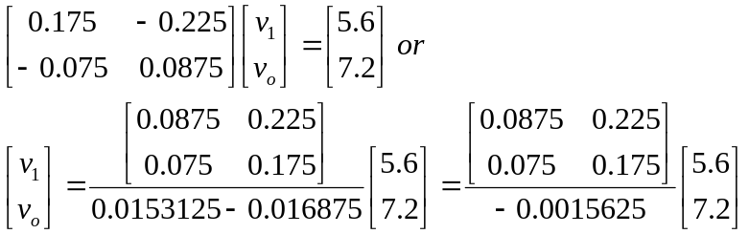

v₁ = –313.6–1036.8 = –1350.4

v_{o} = –268.8–806.4 = –1.0752 kV

and i_{o} = [(v₁–(v_{o}–96))/40] = [(–1350.4–(–1075.2–96))/40] = –4.48 amps.

